Order Of Service

Singing: Psalm 8—CW page 67

Reading: Psalm 104:31-35

Opening Hymn: CW 260

Reading: Acts 21:27-36

Request Hymn: CW Supplement 754

Reading: Matthew 9:9-13

Sermon Hymn: CW 363

Sermon Text: Mark 8:31-33

Suffering And Death

Prayer

The Apostles’ Creed, TLH page 12

Holy Communion

The Lord's Prayer

The Blessing

Closing Hymn: CW 415

* * * * * * * * * * *

Koinonia Hour

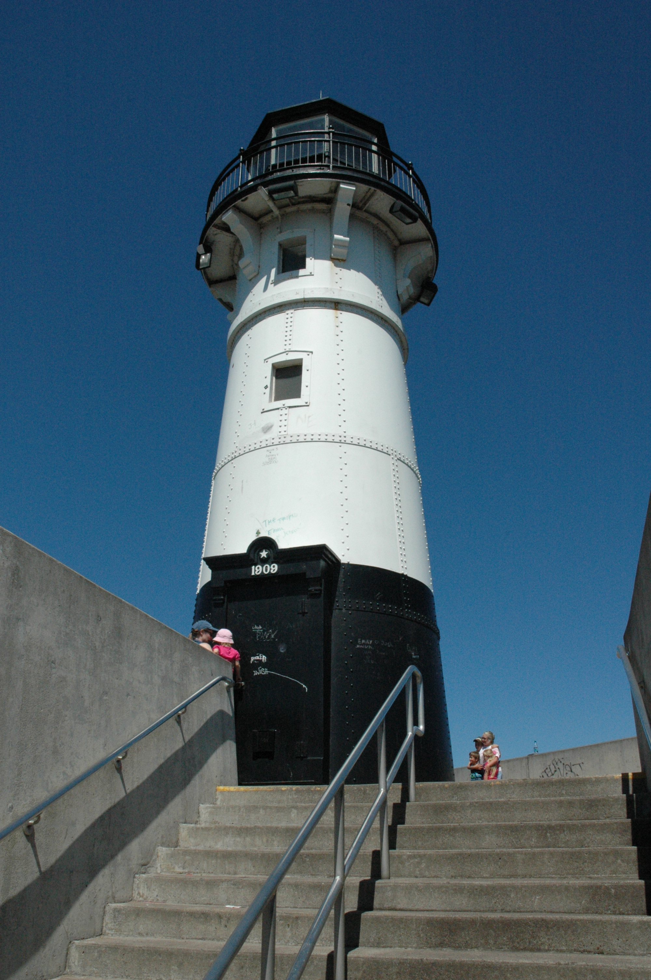

Canal Park, Duluth
Water
Of
Life

4 August 2019

W A T E R O F L I F E

Independent Christian Church—Conservative Lutheran Doctrine

Worship Service: 9:30 a.m. Bible Study: 10:45 a.m.

Larry Cooper, Pastor E-Mail address:
111 N. Ridge Road lcooper@wateroflife.cc
Coon Valley, WI 54623 Web Site:
www.wateroflife.cc

* * * * * * * * * * * * * * * * * * * * * * * * * * *

Sermon Text: Mark 8:31-33

Suffering And Death

* * * * * * * * * * * * * * * * * * * * * * * * * * *

Mark 8:31 And he began to teach them, that the Son of man must suffer many things, and be rejected of the elders, and of the chief priests, and scribes, and be killed, and after three days rise again.
:32 And he spake that saying openly. And Peter took him, and began to rebuke him.
:33 But when he had turned about and looked on his disciples, he rebuked Peter, saying, Get thee behind me, Satan: for thou savourest not the things that be of God, but the things that be of men.

Related Passage: John 18:28-40
John 18:28 Then led they Jesus from Caiaphas unto the hall of judgment: and it was early; and they themselves went not into the judgment hall, lest they should be defiled; but that they might eat the passover.
:29 Pilate then went out unto them, and said, What accusation bring ye against this man?
:30 They answered and said unto him, If he were not a malefactor, we would not have delivered him up unto thee.
:31 Then said Pilate unto them, Take ye him, and judge him according to your law. The Jews therefore said unto him, It is not lawful for us to put any man to death:
:32 That the saying of Jesus might be fulfilled, which he spake, signifying what death he should die.
:33 Then Pilate entered into the judgment hall again, and called Jesus, and said unto him, Art thou the King of the Jews?
:34 Jesus answered him, Sayest thou this thing of thyself, or did others tell it thee of me?
:35 Pilate answered, Am I a Jew? Thine own nation and the chief priests have delivered thee unto me: what hast thou done?
:36 Jesus answered, My kingdom is not of this world: if my kingdom were of this world, then would my servants fight, that I should not be delivered to the Jews: but now is my kingdom not from hence.
:37 Pilate therefore said unto him, Art thou a king then? Jesus answered, Thou sayest that I am a king. To this end was I born, and for this cause came I into the world, that I should bear witness unto the truth. Every one that is of the truth heareth my voice.
:38 Pilate saith unto him, What is truth? And when he had said this, he went out again unto the Jews, and saith unto them, I find in him no fault at all.
:39 But ye have a custom, that I should release unto you one at the passover: will ye therefore that I release unto you the King of the Jews?
:40 Then cried they all again, saying, Not this man, but Barabbas. Now Barabbas was a robber.

